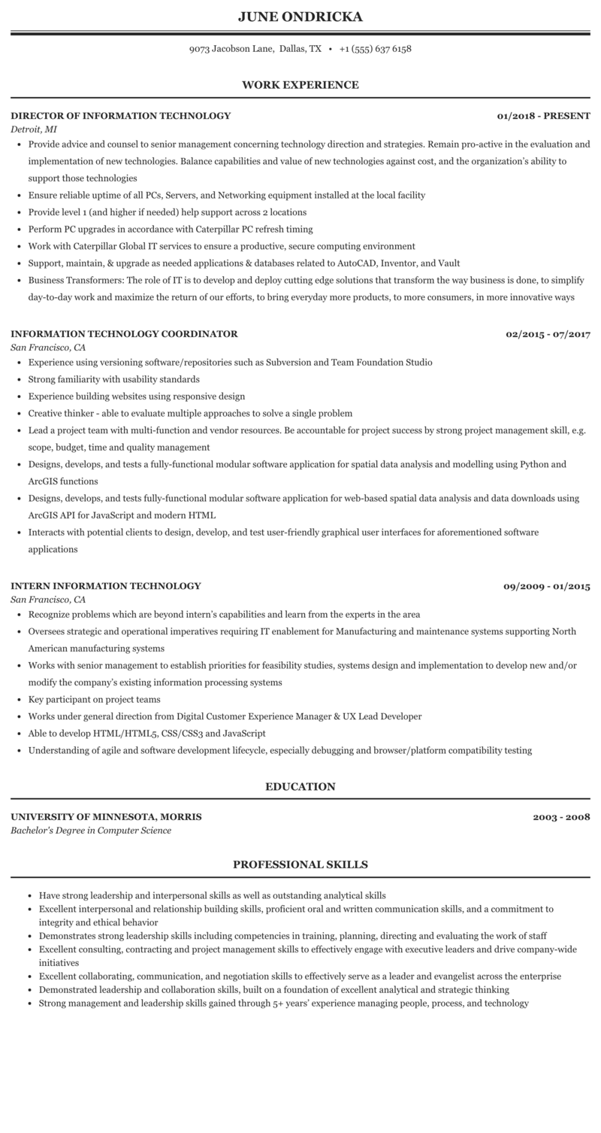
JUNE ONDRICKA
9073 Jacobson Lane, Dallas, TX +1 (555) 637 6158
WORK EXPERIENCE
DIRECTOR OF INFORMATION TECHNOLOGY
Detroit, MI
01/2018 - PRESENT
• Provide advice and counsel to senior management concerning technology direction and strategies. Remain pro-active in the evaluation and implementation of new technologies. Balance capabilities and value of new technologies against cost, and the organization's ability to support those technologies
• Ensure reliable uptime of all PCs, Servers, and Networking equipment installed at the local facility
• Provide level 1 (and higher if needed) help support across 2 locations
• Perform PC upgrades in accordance with Caterpillar PC refresh timing
• Work with Caterpillar Global IT services to ensure a productive, secure computing environment
• Support, maintain, & upgrade as needed applications & databases related to AutoCAD, Inventor, and Vault
• Business Transformers: The role of IT is to develop and deploy cutting edge solutions that transform the way business is done, to simplify
day-to-day work and maximize the return of our efforts, to bring everyday more products, to more consumers, in more innovative ways
INFORMATION TECHNOLOGY COORDINATOR
San Francisco, CA
• Experience using versioning software/repositories such as Subversion and Team Foundation Studio
• Strong familiarity with usability standards
• Experience building websites using responsive design
• Creative thinker - able to evaluate multiple approaches to solve a single problem
02/2015-07/2017
• Lead a project team with multi-function and vendor resources. Be accountable for project success by strong project management skill, e.g. scope, budget, time and quality management
⚫ Designs, develops, and tests a fully-functional modular software application for spatial data analysis and modelling using Python and ArcGIS functions
• Designs, develops, and tests fully-functional modular software application for web-based spatial data analysis and data downloads using ArcGIS API for JavaScript and modern HTML
• Interacts with potential clients to design, develop, and test user-friendly graphical user interfaces for aforementioned software applications
INTERN INFORMATION TECHNOLOGY
San Francisco, CA
• Recognize problems which are beyond intern's capabilities and learn from the experts in the area
09/2009-01/2015
• Oversees strategic and operational imperatives requiring IT enablement for Manufacturing and maintenance systems supporting North American manufacturing systems
• Works with senior management to establish priorities for feasibility studies, systems design and implementation to develop new and/or modify the company's existing information processing systems
⚫ Key participant on project teams
• Works under general direction from Digital Customer Experience Manager & UX Lead Developer
• Able to develop HTML/HTML5, CSS/CSS3 and JavaScript
• Understanding of agile and software development lifecycle, especially debugging and browser/platform compatibility testing
UNIVERSITY OF MINNESOTA, MORRIS
Bachelor's Degree in Computer Science
EDUCATION
PROFESSIONAL SKILLS
2003-2008
• Have strong leadership and interpersonal skills as well as outstanding analytical skills
⚫ Excellent interpersonal and relationship building skills, proficient oral and written communication skills, and a commitment to integrity and ethical behavior
• Demonstrates strong leadership skills including competencies in training, planning, directing and evaluating the work of staff
• Excellent consulting, contracting and project management skills to effectively engage with executive leaders and drive company-wide initiatives
• Excellent collaborating, communication, and negotiation skills to effectively serve as a leader and evangelist across the enterprise
• Demonstrated leadership and collaboration skills, built on a foundation of excellent analytical and strategic thinking
• Strong management and leadership skills gained through 5+ years' experience managing people, process, and technology

